Đề thi Violympic Toán Tiếng Anh lớp 4 vòng 5 năm 2016 - 2017
Bài 1: Điền kết quả thích hợp vào chỗ (...)
Câu 1: The perimeter of the triangle blow is ...... Cm
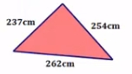
Câu 2: The sum of two numbers is 47 and their difference is 15. The smaller number is ......
Câu 3: The sum of two numbers is 98 and their difference is 24. The greater number is ......
Câu 4: Fill missing number in the blank 54723 + ...... = 27849 + 54723
Câu 5: If the perimeter of a square is 104m then its one side's length is ......m
Câu 6: Find the value of m - n + p for m = 9253, n = 3149 and p = 2674
Câu 7: Find x such that x + 24360 = 41256
Câu 8: Think of a number that if you as 720 to it the answer will be 1427. The number is ......
Câu 9: If X x 125 - X x 25 = 1400 then X = ......
Câu 10: The perimeter of a rectangle is 72cm and its length is 12cm more than its width its lenghth is ......
Bài 2: Cóc vàng tài ba
Câu 1: The smallest 3 - digit number is ......
a) 101 b) 10 c) 100 d) 102
Câu 2: Choose the obtuse angle
Câu 3: Choose the obtuse angle
Câu 4: Choose the right angle
Câu 5: The sum of two numbers is the greatest 2 - digit number and their difference is 13. The greater number is ......
a) 56 b) 58 c) 43 d) 41
Câu 6: The perimeter of a rectangle is 112cm and its length is 8cm more than its width. Its width is ......cm
a) 64 b) 24 c) 48 d) 32
Câu 7: When N is divided by 12, the remainder is 9. When N is divided by 6, the remainder is ......
a) 4 b) 0 c) 3 d) 2
Câu 8: Choose the correct number fill in the blank: 2; 4; 12; 48; ......
a) 84 b) 96 c) 144 d) 240
Câu 9: Think of a number that when added to 12 then the answer is divided by 5 the result is 7. Choose the correct expression of the above situation
a) (x + 12) : 7 = 5
b) x + 12 : 5 = 7
c) x + 12 : 7 = 5
d) (x + 12) : 5 = 7
Câu 10: Think of a number that when added to 12 then the answer is divided by 5 the result is 7. The number is ......
a) 23 b) 12 c) 47 d) 35
Bài 3: Sắp xếp theo thứ tự tăng dần
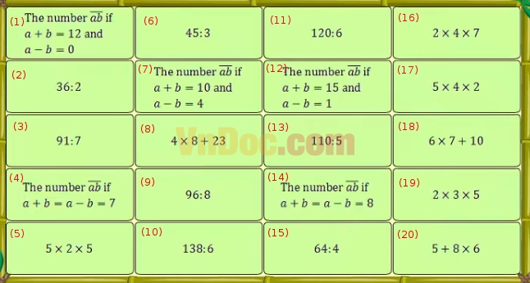
Đáp án
Bài 1: Điền kết quả thích hợp vào chỗ (...)

Câu 1: 753
Câu 2: 16
Câu 3: 61
Câu 4: 27849
Câu 5: 26
Câu 6: 8778
Câu 7: 16896
Câu 8: 707
Câu 9: 14
Câu 10: 24

Bài 2: Cóc vàng tài ba

Câu 1: c
Câu 2: c
Câu 3: d
Câu 4: a
Câu 5: a
Câu 6: b
Câu 7: c
Câu 8: d
Câu 9: d
Câu 10: a

Bài 3: Sắp xếp theo thứ tự tăng dần
9 < 3 < 6 < 15 < 2 < 11 < 13 < 10 < 19 < 17 < 5 < 18 < 20 < 8 < 16 < 1 < 4 < 7 < 14 < 12

