ĐỀ THI VIOLYMPIC TOÁN TIẾNG ANH LỚP 4 VÒNG 2 NĂM 2016 - 2017
Bài 1: Tìm cặp bằng nhau
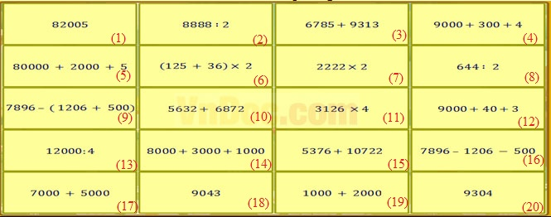
Bài 2: Đỉnh núi trí tuệ
Fill in the blank withn >; <; =
Câu 1: 2 hours 30 minutes... 230 minutes
Câu 2: Compare: 5328... 5283
Write >; =; < in the following blank
Câu 3: 17 - 2 + 4... 6 x 3 + 1
Câu 4: What is the value of 8 in 289 763?
Câu 5: If m = 23 then 123 - m =...
Câu 6: If (a + 15) : 8 = 5 then a =...
Câu 7: Find the value of P if P : 3 x 5 = 1500.
Câu 8: If x < 22 + 23 < x + 2 then x =...
Câu 9: If 2 x a = 10 and 3 x b = 12 then 4 x a + 6 x b =...
Câu 10: 35 x 456 = 400 x 35 + 35 x .... What is the missing number?
Câu 11: It cost $ 15 to buy 3 books. If Nam want to buy 5 books, he must pay $...
Câu 12: Of the 48 students, 21 are girls. How many more boys are there than girls?
Câu 13: The number of pens is twice the number of pencils in a stationery. The number of pencils is 6 times the number of erasers in the shop. How many times is the number os pens as many as the number of erasers?
Câu 14: Jaya is 19 years old. Six years ago her mother was three times as old as her. How old is her mother now?
Câu 15: The product of 3 numbers is 72. If two of the numbers are 2 and 3. What is the third number?
Câu 16: Mr Nam is twice as old as his daughter. If he is 50 years old now, how old will his daughter be in ten years time?
Câu 17: How many even number ar there between 4006 and 4022?
Câu 18: The perimeter of a square is 64cm. How long is each side?
Câu 19: Which of the following is not divisible by 7?
a) 42; b) 63; c) 74; d) 35
Câu 20: Which number's underlined digit is worth 60?
a) 7619; b) 4826; c) 6842; d) 8563
Câu 21: After rounding off the result of a sum to the nearest hundred, the answer is 2500. Which of the following is most likely to be this answer?
a) 25 hundred + 60
b) 24 thousand + 50
c) 24 hundred +50
d) 25 thousand + 50
Câu 22: Which of following numbers is the greatest
a) 4372; b) 4237; c) 4732; d) 4327
Bài 3: Chọn các giá trị theo thứ tự tăng dần
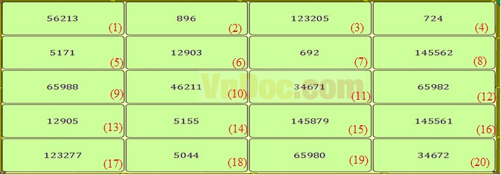
Đáp án
Bài 1: Tìm các cặp giá trị bằng nhau
(1) = (5); (2) = (7); (3) = (15); (4) = (20); (6) = (8); (9) = (16); (10) = (11); (12) = (18); (13) = (19); (14) = (17)
Bài 2: Đỉnh núi trí tuệ

Câu 1: <
Câu 2: >
Câu 3: =
Câu 4: 80000
Câu 5: 100
Câu 6: 25
Câu 7: 900
Câu 8: 44
Câu 9: 44
Câu 10: 56
Câu 11: 25
Câu 12: 6
Câu 13: 12
Câu 14: 45
Câu 15: 12
Câu 16: 35
Câu 17: 7
Câu 18: 16
Câu 19: c
Câu 20: d
Câu 21: c
Câu 22: c

Bài 3: Chọn các giá trị theo thứ tự tăng dần
(7) < (4) < (2) < (18) < (14) < (5) < (6) < (13) < (11) < (20) < (10) < (1) < (12) < (9) < (3) < (16) < (8) < (15)

