Đề thi Violympic Toán Tiếng Anh lớp 4 vòng 3 năm 2015 - 2016
Bài 1: Fill in the blank with the suitable number
Question 1: How many hours are there in 4 days?
Question 2: Calculate: 672g – 276g = ........... g.
Question 3: How many years are in 3 century?
Question 4: There are ................ days in May.
Question 5: Emily write down how many kilometers she walked each day.
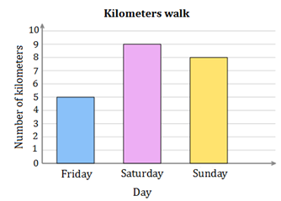
How many kilometers did she walk on Sunday?
Question 6: 765 + … = 459 + 541
The missing number is ..........
Question 7: Write forty-six thousand and fifty using digits.
Bài 2: Cóc vàng tài ba: Choose the most suitable answer in 4 available answers.
Question 1: 1/4 century = ........... years. The missing number is ..............
A. 20 B. 30 C. 25 D. 15
Question 2: What time does the clock shown?

A. 6: 20 B. 4: 06 C. 4: 30 D. 6: 25
Question 3: Find x such that x + 215 = 432
A. 657 B. 647 C. 217 D. 227
Question 4: 5kg = ........... g. The missing number is ...............
A. 5000 B. 50 C. 50000 D. 500
Question 5:
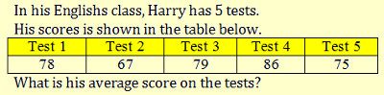

A. 75 B. 79 C. 77 D. 76
Question 6: 5250g + 1750g = ............kg. The missing number is ..............
A. 7 B. 100 C. 70 D. 10
Question 7: If m = 7 then 2000 x 3 + 2000 x m = ..........
A. 9000 B. 20000 C. 2000 D. 20000
Question 8: The average of 75 and M is 82. The value of M is ............
A. 89 B. 86 C. 85 D. 79
Question 9: Today is September 2nd, four days ago is ............
A. August 28th B. August 30th C. August 29th D. August 27th
Question 10:

A. 6 B. 3 D. 5 C. 4
ĐÁP ÁN
Bài 1: Fill in the blank with the suitable number
Question 1: 96 Question 2: 396 Question 3: 300 Question 4: 31
Question 5: 8 Question 6: 235 Question 7: 46050
Bài 2: Cóc vàng tài ba: Choose the most suitable answer in 4 available answers.
Question 1: C Question 2: C Question 3: C Question 4: A
Question 5: C Question 6: A Question 7: B
Question 8: A Question 9: C Question 10: D

