SỞ GIÁO DỤC VÀ ĐÀO TẠO LÂM ĐỒNG  Trường Tiểu học Phước Cát 1  --------------  ĐỀ CHÍNH THỨC  ( Đề kiểm tra có 04 trang) | ĐỀ KIỂM TRA ĐỊNH KÌ CUỐI NĂM  NĂM HỌC: 2015-2016  MÔN: TIẾNG ANH - LỚP 5  Thời gian làm bài: 40 phút

Marks: | Listening |  |  |  |  | Reading and writing |  |  |  | Speaking | Total
Marks: | Q.1 | Q.2 | Q.3 | Q.4 | Q.5 | Q.6 | Q.7 | Q.8 | Q. 9 | Q.10
Comments
…………………………………………………………………………………………………………………………………………………………………………………………………………………………

PART 1: LISTENING (20 minutes) ( 5 points)

Question 1: Listen and number (1 point)

  A. 0 |   B. | 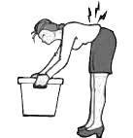  C. |   D. |   E.
Question 2: Listen and write T (True) or F (False) (1 point)

0  T | 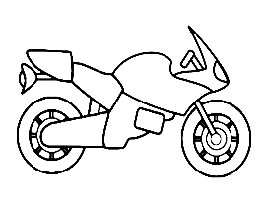  1. | 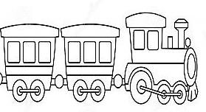  2. |   3. |   4.

Question 3: Listen and draw the lines (1 point)




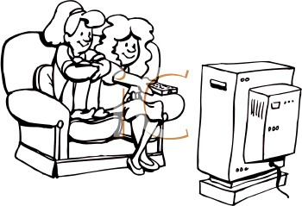
Mary Kate Paul
●
●
●
A
B
C
D
E

                  

Susan John

Question 4: Listen and tick (1 point)
Example: 0. A: What’s the matter with you?

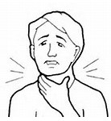
B: I’ve got a

✓
- B. C.

- Mom: Don’t play with
Mary: Don’t worry Mom. It’s friendly.




A. B. C.
- A: What kind of story do you like?
B: I like



B. C.
- A: What will your dream house be like?
B: It’ll be a

B. C.

- A: What does this sign mean? B: It means

A.

Question 5: Listen and complete (1point)

- C.

1. Anna’s (0)....home..... village is in the south of (1)............................
2. It is about (2)......................... ..........................kilometers from Sydney.
3. Anna’s village has got many (3)..............................................................
4. The people in her village are very nice and (4).......................................

PART 2: READING AND WRITING (20 minutes) (5 points)

Question 6: Reorder the words to make a meaningful sentence (1 point)

0. I / got/have/ toothache/ a/./
I have got a toothache.
- did/ you/ How/ get/ to/ your/ hometown/?/
______________________________________________________________________
2. Yesterday/, / went / I/ to/ city/ Ho Chi Minh/. /
______________________________________________________________________
3. I/ surf the Net/ often/ in/ free time/ my /. /
______________________________________________________________________
4. will/ It/ be/ large/ house /a/ in / countryside/ the/. /
_____________________________________________________________________

Question7: Read and tick Yes or No (1 point)
My dream house
Hello, my name is Martin. I want to have a dream house in the countryside. It will be a beautiful house. In front of the house, there will be a large yard. There will also be a flower garden behind the house. There will be six rooms: three bedrooms, one living room, one kitchen and one bathroom. There will be a robot in my dream house. I will use it to do the housework. I will also have a fridge in the kitchen. In the living room, there will be a cable TV and a hi-fi stereo. My dream house will be an ideal one.
Yes No
1. Martin’s dream house will be in the countryside.
✓
2. The house will be in front of the large yard.
3. His dream house will have six rooms.
4. Martin will use a robot to do the homework.
5. There will be a cable car and a hi-fi stereo in the living room.
Question 8: Look at the pictures and complete these sentences (1 point)

1. A: What _____ your dream house be like? 2. It’s often ______ in the summer.
B: It will be a large and beautiful house.
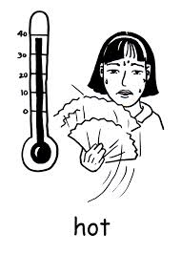



3. Her father often travels to New York 4. It takes Nam _______ hours to get his
by _________. hometown by car.



Question 9: Reorder the sentence to make a conversation (1 point)

Well, go along this street until you can see the correct of Oak Street
and Pine Street. And then turn right into Pine street for 50 meters. It’s
on your left.

Yes, there is. It’s in Pine Street, next to the hospital.

Thank you.
1
Excuse me. Is there a circus near here?

How can I get there?

The end

