Tuyển chọn 20 đề thi kiểm tra Tiếng anh lớp 4
English Test I
Bài 1. Chọn đáp án đúng:
Question1. Let’s …hello to the teacher

A. go
B. say
C.know
D.to

Question2. There is … dog in my house

A. a
B. an
C. two
D.is

Question3. Give …. a pen, please.

A. my
B. my’s
C. me
D. I

Question4. I … reading a book.

A. is
B. are
C. am
D. am’s

Question5. This cake … for you, Mary. – Thank you very much.

A. Is
B. are
C. a
D. an

Question6. Tommy is my friend. He is a …at Quang Trung Primary School.

A. Woker
B. doctor
C. farmer
D. student

Question7. Her house is …big

A. very
B. much
C. many
D. old

Question8. Yoko is …Japan.

A. at
B. under
C. up
D. from

Question9. August is the eighth month … the year.

A. by
B. on
C. of
D.from

Question10. Draw … picture, please.

A. a
B. an
C. a’s
D. an’s

Question11. I … watching television.

A. am
B. is
C. are
D. aren’t

Question12. There … two boys in my class.

A. is
B. are
C. many
D. isn’t

Question13. My birthday is … May 5th.

A. in
B. on
C. of
D. from

Question14. Hello, …Sean

A. my
B. my name
C. I
D. I’m

Question15. I can … a bicycle.

A. rides
B. riding
C. ride
D. ride’s

Question16. How …desks are there in your classroom?

A. any
B. many’s
C. any’s
D. many

Question17. I …two cats

A. has
B. haven’t
C. have
D. hasn’t

Question18. I’m from England. – I’m from England,…

A. and
B. too
C. end
D. two

Question19. You cat …nice.

A. is
B. are
C. an
D. a

Question20. I’m ….America.

A. in
B. a
C. from
D. to

Question21. Thank you very much. – You …welcome.

A. is
B. am
C. are
D.isn’t

Question22. Look at the…, please.

A. board
B. board’s
C. say
D. tell

Question23. Where are you from, Alice? - … from Singapore.

A. My
B. Me
C. Am
D. I’m

Question24. March is the … month of the year.

A. First
B. second
C. third
D. fourth

Question25. What…is it? – It’s white.

A. colours
B. colour
C. colour’s
D. colourn’t

Question26. … do you like Art? – Because I can learn how to draw a picture

A. who
B. when
C. what
D. why

Question27. I … sorry. I’m late

A. is
B. are
C. am
D. not

Question28. The box … blue

A. are
B. aren’t
C. is
D. this

Question29. His father’s birthday is … November.

A. in
B. on
C. of
D. from

Bài 2. Điền từ (hoặc chữ) đúng vào chỗ chấm
How --- are you? – I’m ten years old.
Open the book and r- -d after me, please.
W- -n is your birthday?
This cak- is for you..
Write ab- -t your family, please.
When is Peter’s birthday? – It’s – April.
Happy birthday – you, Tommy. - Thank you ---- much
There is a - - the living room.
Trang - - my friend.
My house is n – w.
Where is Jean from? – He is f- -m France.
How are you t—ay?
What col-ur is this? – It’s red.
Why is Quynh happy? – Becau –e today is her birthday.
My sister is a student at Hoang Mai Pimary Sch---.
Your bedroom is big. How about the bathroom? Is it big t- -?
This gift is for you. - Thank you ---- much.
Wh- -e is David from? – He is from England.
Hello, I’m Alan. How are you? – I’m fine, thanks. --- you?
How old -- your sister? – She is eleven years old.
That is my b-droom.
--- is Alan so happy? - Because today is his birthday.
This is my friend. –r name is Alice.
My sister is twelve year- old.
Thank you very much, Lan Anh. You --- welcome.
Bài 3. SMART MONKEY
Please help the monkey hang the signs under the right boxes from 1 to 10

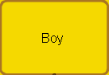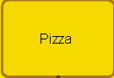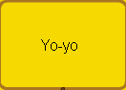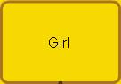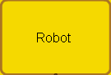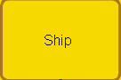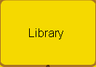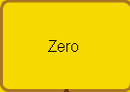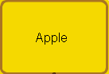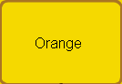

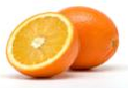



Bài 4. Dùng từ (hoặc chữ) thích hợp điền vào các câu sau
1. That’s _ y friend.
2. What’s her na _ e?
3. Is ___ s yours schoo?
4. She is in the classr __ m.
5. A; How’s the weat __ r today?
B: It’s very hot today.
6. I’m 7 years o __.
7. H __ name is Mary.
8. I am _ rom Singapore.
9. What col __ r is it? – It’s green.
10. Your sch ___ is big.
Bài 5. Put the words or letter in the right order to make a complete sentence or a complete words.

1. 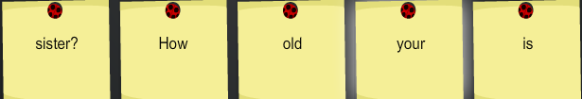

2. 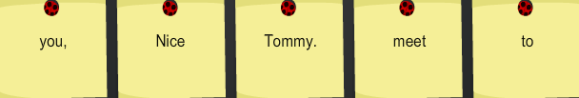

3. 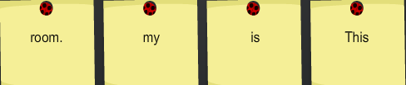

4. 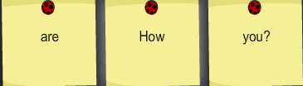

5. 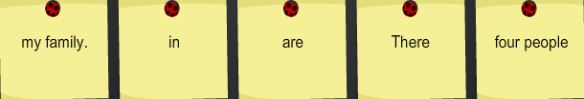

6. 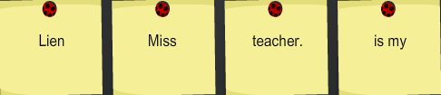

7. 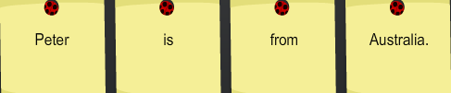

8. 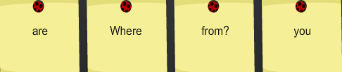

9. 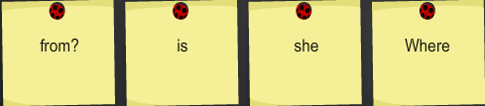

10. 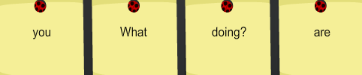

English Test II

Bài 1. Choose the most suitable answer by slecting A, B, C, or D.

1. What is your ......? – My name is Tommy.
A. game B. names C. name D. name’s
2. I’m ..... America.
A. in B. a C. from D. too
3. There .... two boys in my class
A. is B. many C. are D. isn’t
4. Hi, my ..... Alan
A. name is B. names’ C. names D. is name
5. Jimmy is happy because to day is .... birthday
A. her B. she C. his D. he
6. I .... two cats.
A. has B. haven’t C. hasn’t D. have
7. Your cat .... nice
A. is B. are C. an D. a
8. August is the eight month .... the year.
A. by B. on C. of D. from
9. The box .... blue
A. are B. aren’t C. is D. this
10. I ... sorry. I’m late
A. is B. are C. am D. not
Bài 2. Dùng từ (hoặc chữ) thích hợp điền vào các câu sau

1. Wh __ e is David from? – He is from England.
2. My sister is a student at Hoang Mai Primary Sch ___.
3. These crayons a __ for you. – Thank you very much.
4. How are you t __ ay?
5. My house is n _ w
6. This cak _ is for you. – Thank you very much
7. Ha __ y birthday to you, Alan.
8. There are 20 student _ in my classroom.
9. Tha __ you very much.
10. This is my friend. __ r name is Alice.
Bài 3. Dùng từ thích hợp cho trong ô vàng điền vào các tranh sau

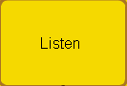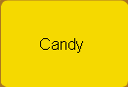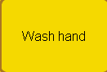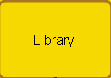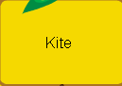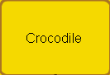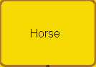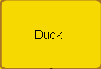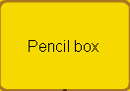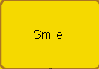

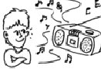

Library

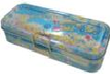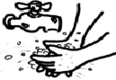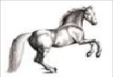

Bài 4. Put the words or letter in the right order to make a complete sentence or a complete words.

1. 

2. 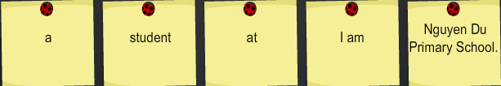

3. 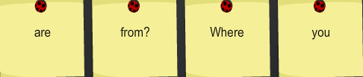

4. 

5. 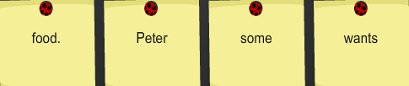

6. 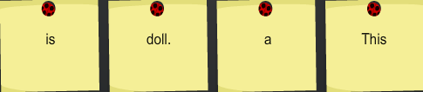

7. 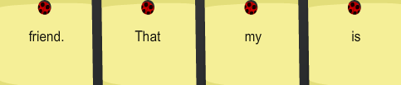

8. 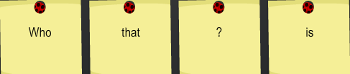

9. 

10. 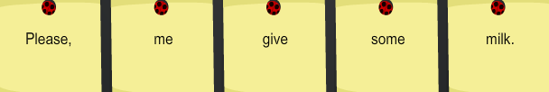

Bài 4. Chữa các từ sau cho đúng:
pactket → |  | banalna →
stasr → |  | birsd →
schpool → |  | broewn →
kitet → |  | whien →
notesbook → |  | whiute →

English Test III
Bài 1. Dùng từ (hoặc chữ) thích hợp điền vào các câu sau
.
1.May I go _ _ ?  2. Wh _ is that? – That’s my sister, Linda.  3. I get _ _ at 6 o’clock.  4. This is my b _ droom.  5. My sister is pre _ _ y.  6. Peter was bo _ n in May. | 7. My mother would like _ banana.  8. What a _ _ _ t some milk? – Yes, please.  9. I can’t dance _ _ _ I can swim.  10. I’m from Vietnam. I can speak _ _ _ _ _ _ _ se.  11. What c _ _ I do with a pen? – You can write.  12. Can you swim? - _ _ , I can’t.
Bài 2. Chữa các từ sau cho đúng:
banalna → |  | lite →
whuere → |  | stutdent →
mielk → |  | whlo →
plearse → |  | whym →
buqs → |  | Einglish →

Bài 3. Dùng từ (hoặc chữ) thích hợp điền vào các câu sau
1. Mary is in the cl _ _ _ _ _ _ m now.
2. I’d like _ _ ice-cream.
3. That is _ bicycle.
4. He was bor _ n in May.
5. I am _ _ om England.
6. Happy bi _ _ _ _ ay to you!
7. _ _ _ _ is it? – It is a chair.
8. Ha can dance b _ _ cannot play football.
9. _ _ _ _ is it? – It is a kite.
10. _ _ _ you swim, Nga? - Yes, I can.
Bài 4. Chọn đáp án đúng
1. Mary studies Maths ….. 7 a.m …… 8 a.m on Sunday.
A. to/at B. from/in C. from/to D. on/to
2. Are they students? – yes, ….
A. they are. B. they do C. are they D. are thier
3. Would you like ….apple? – Yes, please.
A. a B. an C. some D. the
4. Choose the odd one out:
A. May B. April C. June D. Peter
5. Can you swim? - ……
A. No, I can B. No, thanks C. Yes, Ican’t D. yes I can
6. Goodbye, Peter. ……
A. Later see you B. See you later C. See later you D. You see later
7. Can you speak English? - …..
A. Yes, I can’t B. No, I can C. No, I can’t D. Yes, I do
8. I can speak ….
A. Vietnam B. England C. America D. English
9. ….. you like some milk? – Yes, please.
A. Can B. Are C. Is D. Would
10. ….. are you from, Jean? – I’m from Canada.
A. What B. How C. Where D. When

Bài 5. Sắp xếp các từ để hoàn thành câu
1. 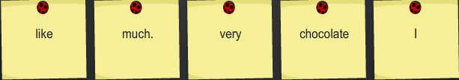

2. 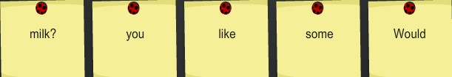

3. 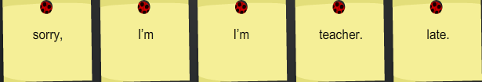

4. 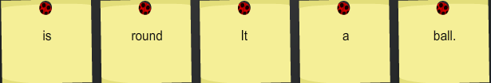

5. 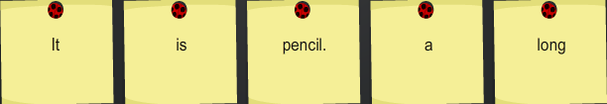

6. 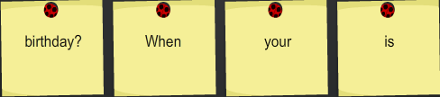

7. 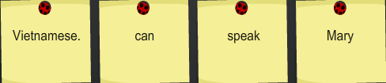

8. 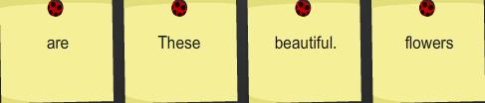

9. 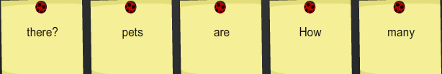

10. 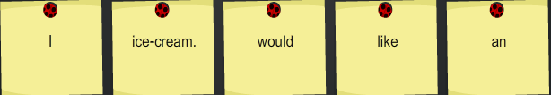

11. 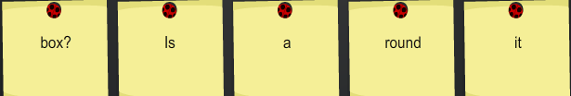

12. 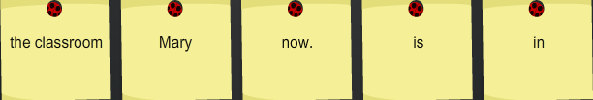

13. 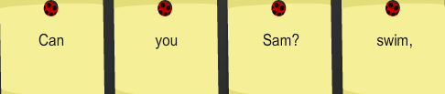

14. 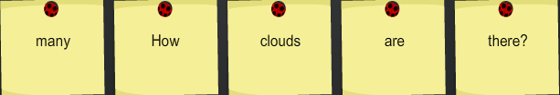

15. 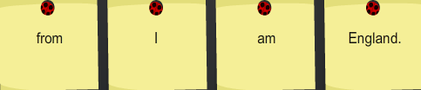

16. 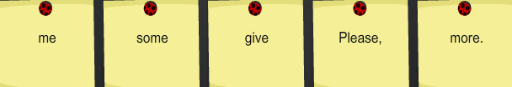

17. 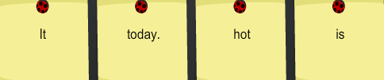

18. 

Bài 6. Dùng từ thích hợp cho trong ô vàng điền vào các tranh sau

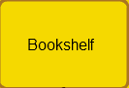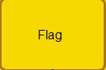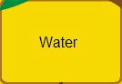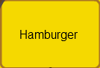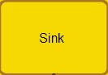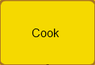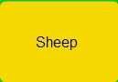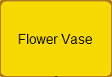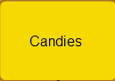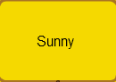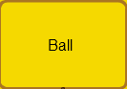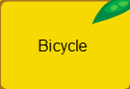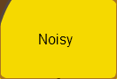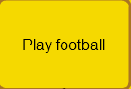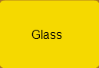

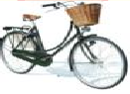

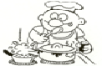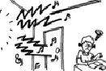

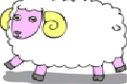

English Test III
Bài 1. Chọn đáp án đúng
1. Choose the odd one out:
A. May B. July C. April D. Jimmy
2. I'd like ........... apple, please.
A. a B. four C. an D. and
3. What does he do ........ Maths lessons?
A. from B. and C. during D. end
4. His book are ...... the table
A. at B. in C. down D. on
5. How ........ books on the table? - There are 3 books.
A. much B. very C. many D. on
6. Where is she to today?
A. She's at school B. She's from Australia
C. She's nine years old D. She's Mary
7. Choose the odd one out:
A. song B. sing C. animal D. tree
8. ......... pens are there in your bag? - There are 2 pens.
A. How old B. When C. How D. How many
9. They live ....... England
A. on B. in C. under D. for
10. What's ...... name? - He's Tommy
A. her B. his C. she D. he
11. This banana is ..... you, Jim.
A. on B. for C. in D. under
12. Thank you very much. - You're .......
A. well B. stay C. welcome D. come
13. Choose the odd one out
A. father B. mother C. teacher D. sister
14. I would like an apple. - Here you .....
A. is B. are C. a D. an
15. Peter can ...... a bike
A. ride B. play C. stay D. drink
16. ............. you like a candy? - No, thanks.
A. Who B. When C. Would D. How
17. I have ....... robot.
A. a B. an C. two D. and
18. I learn ...... to read and write during English lesson.
A. but B. to C. on D. and
19. Are these your books? - No, .....
A. this isn't B. they aren't C. there aren't D. they are
Bài 2. Dùng từ (hoặc chữ) thích hợp điền vào các câu sau
1. My brother lik _ s toys very much.  2. Peter _ _ from Americ _ .  3. I c _ n swim but I can't d _ nce.  4. Can you sp _ _ k English?  5. When is h _ r birthday? | 6. Would you like a cand _ ? - Yes, please.  7. The we _ _ her is fine today.  8. Where _ r _ the dolls?  9. The building is very ta _ l.  10. I was b _ _ n in April.

Bài 3. Chọn đáp án đúng
1. Would you like an ....... ?
A. banana B. apple C. candy D. packet of milk
2. Can you ......... a picture?
A. draw B. look C. on D. when
3. ......... do you live? - I live in Hanoi.
A. How B. When C. Where D. What
4. ......... a round ball
A. Is it B. It's C. What is D. They are
5. Peter can .... a bike.
A. I B. is C. ride D. ride's
6. Do you like a ......... ? - Yes, I do.
A. biscuit B. football C. house D. this
7. What ........ is this bag? - It's white.
A. you B. colour C. birthday D. old
8. What can ...... do? - I can dance and sing
A. I B. he C. you D. Me

English Test IV
Bài 1. Khoanh tròn một từ khác loại. (1 điểm)
1. A. Speak | B. Song | C. Play | D. Swim
2. A. Countryside | B. City | C. Street | D. Map
3. A. Milk | B. Chicken | C. Bread | D. Fish
4. A. August | B. November | C. May | D. Match
5. A. Maths | B. English | C. Science | D. Vietnam

Bài 2. Chọn một đáp án thích hợp nhất. (2 điểm)
1.Where are you today?
A. I’m at home |  |  | B. I’m from Vietnam |  |  | C. I’m ten years old
2. How many students are there in Mai’s class?
A. There are 30 students |  | B. There is a teacher |  | C. There are 30 students in his class
3. Can your mother speak English ?
A. Yes , I can |  |  | B. No , she can’t |  |  | C. No , he can’t
4. Would you like ……………….. orange juice?
A. some |  |  | B. an |  |  | C. a
5. When is your birthday?
A. It’s in September | B. It’s in September 2nd |  |  |  | C. Your birthday’s in September

Bài 3. Đặt câu hỏi cho các câu trả lời sau. (2 điểm)
- Yes, I’d like some milk. ____________________________________________
- He has Maths and Art on Monday. ____________________________________________
3. Because I like to sing songs. ____________________________________________
4. There are four books on my desk. ____________________________________________
5. My pen friend is from America. ____________________________________________
Bài 4. Nối câu ở cột A với câu ở cột B sao cho phù hợp. (1 diểm)
A | B | A-> B
1. What sports do you like? | A. I am ten | 1 ->
2. Can you draw a picture? | B. I like football | 2 ->
3. How old are you? | C. I have it on Tuesday | 3 ->
4. When do you have Vietnamese? | D. I have ten | 4 ->
5. How many pens do you have? | E. No, I can’t | 5 ->

Bài 5. Sắp xếp các từ sau thành câu hoàn chỉnh. (2 điểm)
1. doll / for / This/ you/ is. ____________________________________________
2. is / My / classroom / big. ____________________________________________
3. subjects / What / like / he/ does? ____________________________________________
4. you / do / like / Why/ English? ____________________________________________
5. was / I / in/ April / born. ____________________________________________
Bài 6. Điền từ còn thiếu vào chỗ trống. (2 điểm)
1. What do you do ………. Science lessons? | 4. He is …………… Australia.
2. There …………. three maps on the wall. | 5. I can ……….. a bike.
3. She ………… like Maths because it’s difficult.

English Test V

I. Choose the best option A, B, C or D
1. What ……….. is it? – It’s 7.30 a.m.
A. color B. time C. nationality D. name
2. It’s time to go …….. a walk.
A. to B. at C. for D. on
3. Nam gets up …….. 6 o’clock every morning.
A. at B. on C. from D. to
4. What time do ……… go to school every day? – I go to school at 6.30.
A. he B. she C. you D. they
5. I …….. breakfast at 6.15 every morning.
A. do B. learn C. go D. have
6. She ……… TV in the evening.
A. watches B. reads C. opens D. goes
7. What is his job? – He is ……… factory worker.
A. his B. a C. an D. one
8. This is a photo ……… my family.
A. from B. at C. in D. of
9. ……….. does your father do? – He is a doctor.
A. What time B. What C. How D. Where
10. My brother drives a bus. He is a bus ………… .
A. teacher B. businessman C. farmer D. driver
11. …….. does your mother work? – She works in a primary school.
A. Where B. What C. How D. Why
12. What’s your ……….. food? – I like chicken.
A. good B. favorite C. nice D. small
13. ………. you like some orange juice? – Yes, please. I love it.
A. Do B. Are C. Would D. About
14. What …….. she like? – She’s very nice.
A. are B. am C. is D. to be
15. My mother is a ……… teacher. She is kind and friendly, too.
A. small B. big C. thin D. good
16. What does he look like? – He looks ………. .
A. sporty B. friend C. student D. pretty
17. What is Christmas? – It is ………. .
A. a festival for children C. a big festival
B. a festival for teachers D. a popular festival in Vietnam
18. There …….. a lot of fun on festivals.
A. is B. are C. am D. have
19. We ………. our teachers and friends on Tet holidays.
A. go B. visit C. get together D. eat
20. What are you going to do at Mid-Autumn? – I …….. the School Lantern Parade.
A. join B. am going to join C. go to join D. go and join
21. He is very happy ………. the New Year is coming.
A. and B. or C. because D. by
22. ………. is the fireworks display? – It’s colorful and beautiful.
A. How B. What C. Where D. Why
23. What ……… is this? – It’s an elephant.
A. crocodile B. tree C. fruit D. animal
24. What are monkeys ………. ? – They are quick and clever.
A. do B. can C. like D. look
25. Bears like ………….. fish, fruit and honey.
A. eats B. eat C. eating D. are eating
26. Bears can ……….. on two legs and move around.
A. to stand B. stand C. stands D. standing
27. Lets’ go to the ………… . I want some books.
A. bookshop B. post office C. cinema D. supermarket
28. …….. do you want to the post office? – Because I want some stamps.
A. When B. What time C. Why D. Who
29. ………. is she wearing? – She’s wearing a pink dress.
A. Where B. What C. Who D. How
30. She ……… got brown hair.
A. have B. has C. having D. to have
31. ……….. are Peter and Mary? – They are at the school party.
A. Who B. What C. Where D. What time
32. What ………. are Linda’s shoes? – They are white.
A. clothes B. jeans C. weather D. color
33. ……….. is the T-shirt over there? – It’s 150.000 dong.
A. Why B. How much C. How D. What
34. What are you ……….. ? – I am reading.
A. reading B. drawing C. doing D. singing
35. They are going to ……… some sports and games.
A. read B. dance C. walk D. play
36. ……… do you prefer, badminton or football?
A. Where B. How C. What D. Which
37. Where ……. you go last summer? – I went to Nha Trang with my aunt.
A. do B. does C. did D. are
38. ……. did you come back from Singapore? – I came back last weekend.
A. Who B. When C. How D. Why
39. My brother goes ………. in the summer.
A. fishing B. fish C. to fish D. fishes
40. I often do my homework …….. the evening.
A. from B. at C. in D. on
41. This weekend we are going ……. a picnic with our new friends.
A. from B. for C. of D. with
42. Can I have a look at the shirt?
A. I don’t know. b. Sure. Here you are. C. Don’t look. D. Fine, thanks.
II. Reorder the words to make sentences.
1. elephants / because / they / I / bulky. / like / are / don’t
………………………………………………………………
2. apple juice?/ like / some / Would / you
………………………………………………………………
3. join / School / the / I’m / going to / Lantern Parade.
………………………………………………………………
4. you/ Ho Chi Minh city? / When / come / back / did / from
………………………………………………………………
5. with my / play football / friends / on Sunday. / I often
................................................................................................
6. my uncle / weekend / my house. / Last / stayed at
.....................................................................................................................................
7. T-shirt/wearing/and/He’s/jeans./a
.....................................................................................................................................
8. and mountains / country. / in my / a lot of rivers / There are
.....................................................................................................................................
9. usually stay / Do they / by the sea? / in a small house / or flat
.....................................................................................................................................
10. their friends / What do / like to / talk / about?
.....................................................................................................................................
11. the season / What / is / in Vietnam? / of fruits
.....................................................................................................................................
12. I often / play football / friends / with my / on Sunday.
.....................................................................................................................................
13. afraid / is very / of / dogs. / My son
.....................................................................................................................................
14. have any / doesn’t / books in / She / her schoolbag.
.....................................................................................................................................
15. like me / that for / Would you / you? / to do
.....................................................................................................................................
16. having a / wonderful / I’m / in Ho Chi Minh City. / time
.....................................................................................................................................
17. room? / your / wide / How / is
.....................................................................................................................................
18. much / gives us / today. / Our teacher / homework
.....................................................................................................................................
19. some / in the / garden. / There are / frogs
.....................................................................................................................................
20. on schooldays. / never / fishing / goes / Long
.....................................................................................................................................
21. good / very / My father / worker. / is a
.....................................................................................................................................
22. What / Hanoi today? / the weather / like in / is
.....................................................................................................................................
23. about their / news / have some / exams. / The students
.....................................................................................................................................
24. behind / my house. / any tall / trees / There aren’t
.....................................................................................................................................
25. eyes? / are your / baby’s / What / colour
.....................................................................................................................................
26. to many / the world. / to travel / They want / places in
.....................................................................................................................................
27. What / Summer? / usually / do in / do you
.....................................................................................................................................
28. tell me / the way / to the / Can you / hospital?
.....................................................................................................................................
29. to be / wants / My / brother / a footballer.
.....................................................................................................................................
30. for / How often / are you / late / school?
.....................................................................................................................................
31. in her / shopping / often goes / free time. / My mother
.....................................................................................................................................
32. years? / you begin / school / When do / the new
.....................................................................................................................................
33. wear / in the winter. / clothes / warm / We always
.....................................................................................................................................
34. uncle plant / garden?/ many flowers / Does your / in the
……………………………………………………………………………………….
35. can you / for me? / go to the / supermarket to / buy some fruit /
.....................................................................................................................................
36. music / to /you listen / last night? / Did/
.....................................................................................................................................
37. a year. / always / a picnic twice / My classmates / have /
.....................................................................................................................................
38. no / There are /in / girls / his class./
.....................................................................................................................................
39. to work / Many people /for their / walk / health.
.....................................................................................................................................
40. her / are / hats. / new / Those
.....................................................................................................................................
41. I’m / now. / house / drawing / my dream /
…………………………………………………………...…………………………..
42. after/ doing / aerobics? / she feel / How does /
………………………………………………………………………………………
43. is / for / nice / The sea / swimming.
…………………………………………..…………………………………………..
44. is / with / What / you? / the matter
………………………………………….…………………………………………...
45. You should / go out. / warm clothes / wear your / when you
.....................................................................................................................................
46. he get / in the / morning? / up early / Why does/
.....................................................................................................................................
47. eat / You mustn’t / food / in the / classroom. /
.....................................................................................................................................
48. seasons / your country? / are / How many / there in /
….....................................................................................................................................
49. go to / by bus. / school/ They / usually/
.....................................................................................................................................
50. get up/ What time / morning? / does your daughter/ in the
.....................................................................................................................................

III. Odd one out
1. a. an elephant b. a bear c. a giraffe d. crocodiles
2. a. thirsty b. thirteen c. fifty d. twenty
3. a. hospital b. school c. field d. factory worker
4. a. a shirt b. a dress c. trousers d. a skirt
5. a. lemonade b. bread c. fried chicken d. noodles
6. a. New Year b. mooncake c. Children’s Day d. Tet
7. a. careful b. cheerful c. bulky d. lovely
8. a. medicine b. raincoat c. a camera d. an umbrella
IV. Fill in the blanks with the given words

giraffes sporty swing T-shirt market zoo animals sweets

1. Today, Linda is wearing a _________(1), jeans and shoes. She looks __________(2). Tet is coming soon. She goes to Tet _______(3) with her mother because she wants some _______(4) and fruit.

2. I am Mai . I often go to the (5)__________ with my mother. I like monkeys because they can (6)________. My mother likes (7)________ because they are pretty. We like (8)_________ very much.

books fruit doll stamps toys shop
3. Li Li and Peter want to do shopping. First, they go to the (1) __________ because Li Li wants to buy a new (2) ___________. Second, they go to the post office. They want some (3) _________ . Third, they go to the bookshop. Peter wants some (4) ______. Finally, they go to the supermarket because they want some (5) ________ .
V. Read the passage and then choose the best answer to fill in each blank
There (1) many places near our school: a post office, a supermarket, a food stall and a bookshop. We go to the (2) to buy stamps and (3) letters. We go to the (4) to buy books, pens, and (5) . We go to the supermarket to (6) some shopping. Well, I (7) very hungry and I want to eat now. Let’s go to the (8) .
1. A. am B. is C. are D. be
2. A. supermarket B. food stall C. bookshop D. post office
3. A. buy B. like C. send D. eat
4. A. supermarket B. food stall C. bookshop D. post office
5. A. milk B. stamps C. meat D. pencils
6. A. eat B. do C. send D. buy
7. A. is B. am C. are D. be
8. A. supermarket B. food stall C. bookshop D. post office

