|  |  |  |  |  |  |  |
| --- | --- | --- | --- | --- | --- | --- |
| **SỞ GIÁO DỤC & ĐÀO TẠO TP.HCM** | | | | | **ĐỀ KIỂM TRA GIỮA HỌC KỲ II** |  |
| **TRƯỜNG THPT NGUYỄN DU** | | | | | **Môn: Toán 12** |  |
|  |  |  |  |  | *Thời gian làm bài: 45 phút* |  |
|  | **ĐỀ CHÍNH THỨC** | | |  |  |
|  |  | *(20 câu trắc nghiệm và 5 câu tự luận)* |  |
|  |  |  |  |  | *(Học sinh không được sử dụng tài liệu)* |  |
|  |  | **Mã đề thi 132** |  |  |  |
|  |  |  |  |  |  |
|  |  |  |  |  |  |  |

Họ và tên học sinh:…………………………………………..Số báo danh:……………………

**Phần I: 20 câu trắc nghiệm** (5 điểm)

**Câu 1:** Phương trình mặt phẳng đi qua điểm M(1; 4;– 3) và chứa trục Oy là

**A.** x + y + z–2 = 0 **B.** 3x–z = 0 **C.** 3x + z = 0 **D.** y–4 = 0

**Câu 2:** Cho mặt phẳng (P): 2x + 3y – 2z + 5 = 0 . Tọa độ của vectơ pháp tuyến mặt phẳng (P) là

|  |  |  |  |  |  |  |  |  |  |  |  |  |  |  |  |  |
| --- | --- | --- | --- | --- | --- | --- | --- | --- | --- | --- | --- | --- | --- | --- | --- | --- |
| **A.** (2;2;3) | | |  |  |  | **B.** (2;3; 2) |  | **C.** (2;3;2) | | | |  |  |  | **D.** (3; 2;2) |  |
| **Câu 3:** Tìm họ nguyên hàm:F(x) | | | | | | |  | dx | |  |  |  |  |  |  |  |
|  |  |  |  |  |  |  |  |  |  |
|  |  |  |  |  |  |  |  |  |  |
| x | 2 ln x 1 | |  |  |  |  |  |  |  |
|  |  |  |  |  |  |  |  |  |  |  |  |  |  |
| **A.** F(x) | | |  |  |  C | |  | **B.** F(x)2 | | | |  |  |  C | |  |
| 2ln x  1 | |  | 2ln x  1 | |  |
| **C.** F(x) | 1 |  |  |  | |  C |  | **D.** F(x) | | 1 |  |  |  | |  C |  |
|  |  | 2 ln x  1 | |  | 2 ln x  1 | |  |
|  |  | 4 |  |  |
| 2 | |  |  |  |  |  |  |  |  |  |  |  |  |  |  |



**Câu 4:** Phương trình mặt phẳng đi qua ba điểm M(–1; 2; 3), N(2 ;–4 ; 3), P(4 ; 5; 6) là

**A.** 3x–2y + z + 4 = 0 **B.** 18x + 9y–39z–117 = 0 **C.** 18x + 9y–39z + 117 = 0 **D.** 3x–2y + z–17 = 0

**Câu 5:** Cho hai điểm A(2; 3; 7) và B(4; 1; 3). Phương trình mặt phẳng trung trực của đoạn thẳngAB là

**A.** x–y–2z + 9 = 0 **B.** x–y–2z + 15 = 0 **C.** x–y–2z + 3 = 0 **D.** x–y–2z + 10 = 0

|  |  |  |  |  |  |  |  |  |  |  |  |  |  |  |  |  |  |  |  |  |  |  |  |  |  |  |  |  |  |  |  |  |  |  |  |  |  |  |  |  |  |  |  |  |  |  |  |  |
| --- | --- | --- | --- | --- | --- | --- | --- | --- | --- | --- | --- | --- | --- | --- | --- | --- | --- | --- | --- | --- | --- | --- | --- | --- | --- | --- | --- | --- | --- | --- | --- | --- | --- | --- | --- | --- | --- | --- | --- | --- | --- | --- | --- | --- | --- | --- | --- | --- |
|  |  |  |  |  |  |  |  |  |  |  | 1 | | | | | | | |  |  | (3x 1) | | | | | | | | |  |  |  |  |  |  |  |  |  |  |  |  |  |  |  |  |  |  |  |
| **Câu 6:** Tính tích phânI | | | | | | | | | | | | | | | | | | |  |  |  | dx |  |  |  |  |  |  |  |  |  |  |  |  |  |  |  |  |  |
|  |  |  |  |  |  |  |  |  |  |  |  |  |  |  |  |  |  |  |  |  |  |  |  |  |  |  |  |  |
|  |  | 2 |  |  |  |  |  |  |  |  |  |  |  |  |  |  |  |  |  |  |  |  |  |  |  |  |  |  |
|  |  |  |  |  |  |  |  |  |  |  | 0 | | | | | | | |  | x |  | 6x  9 | | | | | | | | |  |  |  |  |  |  |  |  |  |  |  |  |  |  |  |  |  |
| **A.** 3ln | 3 | − | 5 |  |  |  |  |  |  |  |  |  |  |  |  |  |  | **B.** 3ln | | | | |  | 4 | |  |  | | 5 |  |  |  |  | **C.** 3ln | 3 |  | 5 |  |  |  |  |  | **D.** 3ln | 4 | − | 5 |  |  |
| 4 | |  | 6 |  |  |  |  |  |  |  |  |  |  |  |  |  |  |  |  |  |  |  | 3 | | |  | 6 | | |  |  |  |  | 4 | |  | 6 |  |  |  |  |  |  | 3 |  | 6 |  |  |
| **Câu 7:** Cho biết0 | | | | | | |  |  |  |  | x 1 | | | | |  |  | dx  a ln | | | | | | | b | |  | 1 , với a, b, c là các số nguyên. Tính S = a + b + c | | | | | | | | | | | | | | | | | | | |  |
|  |  |  |  |  |
| x  2 | | | | | | c | |  |  |
|  |  |  |  |  |  | 1 |  |  |  |  |  |  | |  |  |  |  |  |  |  |  |  |  |  |  |  |  |  |  |  |  |  |  |  |  |  |  |  |  |  |
|  |  |  |  |  |  |  |  |  |  |  |  |  |  |  |  |  |  |  |  |  |  |  |  |  |  |  |  |  |  |  |  |  |
| **A.** S = 10 | | |  |  |  |  |  |  |  |  |  |  |  |  |  |  |  | **B.** S = 6 | | | | | | | | |  |  |  |  |  |  |  | **C.** S = 8 | | |  |  |  |  |  |  | **D.** S = 4 | |  |  |  |  |
| **Câu 8:** Họ nguyên hàm của hàm sốf (x) | | | | | | | | | | | | | | | | | | | | | | | | | | | | | | | | 1 |  | là | | |  |  |  |  |  |  |  |  |  |  |  |  |
| x 1 | |  |  |  |  |  |  |  |  |  |  |  |  |
|  |  |  |  |  |  |  |  |  |  |  |  |  |  |  |  |  |  |  |  |  |  |  |  |  |  |  |  |  |  |  |  |  |  |  |  |  |  |  |  |  |  |  |  |  |  |  |
| **A.** f (x)dxln | | | | | | | |  |  | x  1 | | | |  |  C | | | | |  |  |  |  |  |  |  |  |  |  |  |  |  |  | **B.** f (x)dx  | | | | | 1 |  |  |  |  C |  |  |  |  |  |
|  |  |  |  |  |  |  |  |  |  |  |  |  |  |  |  |  |  |  |  |  |  |  |  |  |
|  | |  |  |  |  |  |  |  |  |  |  |  |  |  |  |  |  |  |  |  |  |  |  |  |  |
|  |  |  |  |  |  |  |  |  |  |  |  |  |  |  |  |  | (x  | 1) | | 2 |  |  |  |  |  |
|  |  |  |  |  |  |  |  |  |  |  |  |  |  |  |  |  |  |  |  |  |  |  |  |  |  |  |  |  |  |  |  |  |  |  |  |  |  |  |  |  |  |  |  |  |  |
| **C.** f (x)dx | | | | |  | x  1 | | | | | |  |  C | | | | | | |  |  |  |  |  |  |  |  |  |  |  |  |  |  | **D.** f (x)dx  | | | | | 1 |  |  C | | |  |  |  |  |  |
|  |  |  |  |  |  |  |  |  |  |  |  |  |  |  |  |  |  |  |  |  |
|  |  |  |  |  |  |  |  |  |  |  |  |  |  |  |  |  |  |  |  |  |  |  |
|  |  |  |  |  |  |  |  |  |  |  |  |  |  |  |  |  |  |  |  | 2017 π | | |  |  |  |  |  |  |  |  |  |  |  |  |  |  |  |  | x 1 | | |  |  |  |  |  |  |  |
|  |  |  |  |  |  |  |  |  |  |  |  |  |  |  |  |  |  |  |  |  |  |  |  |  |  |  |  |  |  |  |  |  |  |  |  |  |  |  |  |  |  |  |
|  |  |  |  |  |  |  |  |  |  |  |  |  |  |  |  |  |  |  |  |  |  |  |  |  |  |  |  |  |  |  |  |  |  |  |  |  |  |  |  |  |  |  |  |  |  |
| **Câu 9:** Giá trị của tích phân | | | | | | | | | | | | | | | | | | | |  |  | ⇩ |  | sin xdx bằng | | | | | | | | | |  |  |  |  |  |  |  |  |  |  |  |  |  |  |  |
|  |  |  |  |  |  |  |  |  |  |  |  |  |  |  |  |  |  |  |  |  | 2 π | |  |  |  |  |  |  |  |  |  |  |  |  |  |  |  |  |  |  |  |  |  |  |  |  |  |  |
| **A.** 1 | | |  |  |  |  |  |  |  |  |  |  |  |  |  |  |  | **B.** 2 | | | |  |  |  |  |  |  |  |  |  |  |  |  | **C.** 0 | | |  |  |  |  |  |  | **D.** –1 |  |  |  |  |  |

Trang 1/2 - Mã đề thi 132

**Câu 10:** Trong hệ trục tọa độ Oxyz. Cho vectơOM2 ik;ON2 j3i, vớii , j, klà vectơ

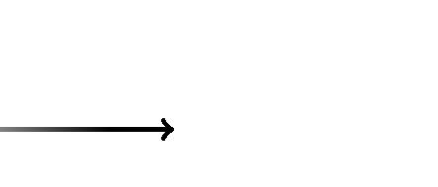

|  |  |  |  |  |  |  |
| --- | --- | --- | --- | --- | --- | --- |
| đơn vị. Tọa độ của vectơ MN là | | | |  |  |  |
| **A.** (5;2;1) | | **B.** (5; 2;1) | | **C.** (5; 2;1) | | **D.** (5; 2;1) |
| **Câu 11:** Cho hai vectơu(1;2;3)vàv(0; 2;3). Tọa độ tích có hướng[u, v]là | | | | | | |
| **A.** (1;3;2) |  | **B.** (1;3; 2) | | **C.** (0;3; 2) | | **D.** (0;3; 2) |
| **Câu 12:** Cho hàm số f(x) có đạo hàm trên [1; 4], f(1) = 10 và4 | | | | | | f '(x)dx 15 . Giá trị của f(4) bằng |
|  |  |  |  |  | 1 |  |
| **A.** –25 |  | **B.** 25 |  | **C.** –5 |  | **D.** 5 |
| **Câu 13:** Cho6 | f (x)dx  9 và 6 | | f (x)dx  5 . Giá trị của 3 | | f (x)dx bằng | |
| 1 |  | 3 |  | 1 |  |  |
| **A.** 14 |  | **B.** –4 | | **C.** 4 |  | **D.** –14 |

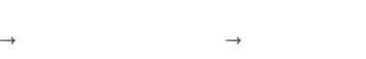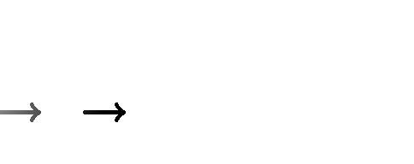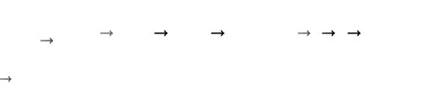

**Câu 14:** Cho vectơu2 i3 j2k, vớii , j, klà vectơ đơn vị của hệ trục tọa độ Oxyz. Khi đótọa độ của vectơ u là

|  |  |  |  |  |  |  |  |  |  |  |  |  |  |  |  |  |  |  |  |  |  |  |  |
| --- | --- | --- | --- | --- | --- | --- | --- | --- | --- | --- | --- | --- | --- | --- | --- | --- | --- | --- | --- | --- | --- | --- | --- |
| **A.** (2;3; 2) | | |  | **B.** (3; 2;2) | | | | | | | | | **C.** (2;2;3) | | |  |  | **D.** (2;3;2) | | | |  |  |
|  |  |  |  |  | π | | |  |  | 6 tan x | | |  |  |  |  |  |  |  |  |  |  |  |
|  |  |  |  |  |  |  |  |  |  |  |  |  |  |  |  |  |  |  |  |  |
| **Câu 15:** Cho tích phânI04 | | | | | | |  |  |  | dx . Giả sử đặt: t  3tan x 1 thì ta được | | | | | | | | | |  |
|  |  |  |  |  |  |  |
|  |  | 2 |  |  |  |  |
| cos | | x 3 tan x 1 | | |  |
|  |  |  |  |  |  |  |  |  |  |  |  |  |  |  |  |  |  |  |
| **A.** I | 4 | 12 t2 | 1dt | **B.** I | | | | 4 | | 12 t2 1dt | | | **C.** I | 4 | 12 2t2 | 1dt | | **D.** I | | 4 | 12 2t2 | 1dt |  |
|  | 3 | |  |  |  |
| 3 | |  |  |  |  |  |  |  |  |  | 3 | |  |  |  | 3 | | |  |  |  |



**Câu 16:** Cho mặt phẳng (P): x –2y + 2z– 2 = 0 và mặt cầu (S): x2+ y2+ z2+ 6x–8y + 2z + 1 =

1. Viết phương trình mặt phẳng (Q) song song với mặt phẳng (P) và tiếp xúc với mặt cầu (S)

**A.** x–2y + 2z + 28 = 0 **B.** x–2y + 2z–28 = 0 **C.** x–2y + 2z + 84 = 0 **D.** x–2y + 2z–84 = 0

**Câu 17:** Cho hai điểm A(1; 3; – 2) và B(1; –1; 1).Độ dài của đoạn thẳng AB là

**A.** 9 **B.** 25 **C.** 3 **D.** 5

**Câu 18:** Cho tam giác ABC có A(1; 2; 3), B(–1; 2; 0), C(3;– 4; 3). Tọa độ trọng tâm G của tamgiác ABC là

**A.** (1;0; 2) **B.** (3;0; 2) **C.** (1;0;6) **D.** (3;0;6)

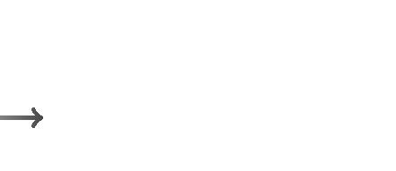

**Câu 19:** Phương trình mặt phẳng đi qua điểm M(1; – 2; 4) và có vectơ pháp tuyếnn(2;3;5)là

|  |  |  |
| --- | --- | --- |
| **A.** 2x + 3y + 5z | + 16 = 0 | **B.** 2x + 3y + 5z–16 = 0 |
| **C.** 2x + 3y + 5z | – 3 = 0 | **D.** 2x + 3y + 5z + 3 = 0 |

**Câu 20:** Cho phương trình mặt cầu (S):(x–2)2+ (y + 1)2+ (z + 3)2= 4. Tọa độ tâm I và bánkính R của mặt cầu (S) là

**A.** I(2;1;3), R4 **B.** I(2;1;3), R2 **C.** I(2;1;3), R4 **D.** I(2;1;3), R2

**Phần II: 5 câu tự luận** (5 điểm) (học sinh nhớ ghi mã đề trên giấy làm bài)

**Bài 1:** Tìm nguyên hàm F(x) của hàm số f(x) = 3x2+ 2, biết F(1) = 2.

**Bài 2:** Tính các tích phân sau:

|  |  |  |  |  |  |  |  |  |  |  |
| --- | --- | --- | --- | --- | --- | --- | --- | --- | --- | --- |
|  |  | 1 |  |  |  |  | π | |  |  |
| a) | A  (x  1)(x  3)dx | | | |  |  |  |  |  |  |
|  | 2 | |  |  |  |
|  |  | 0 |  |  | b) | B  (x  cos x)dx | | | |  |
|  |  |  |  |  |  | 0 | |  |  |  |
| c) | C  | e2 | ln x 1 | dx | d) | D  1 | | | x.e x dx |  |
|  |  |
|  |  | e x.ln x | | |  | 0 | | |  |  |

----------- HẾT ----------

Trang 2/2 - Mã đề thi 132

**PHIẾU ĐÁP ÁN TRẮC NGHIỆM GIỮA HỌC KỲ II**

**MÔN TOÁN**

**Mã đề: 134**

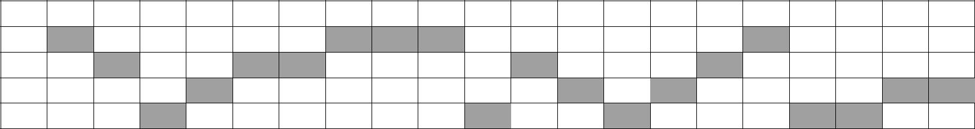

|  |  |  |  |  |  |  |  |  |  |  |  |  |  |  |  |  |  |  |  |
| --- | --- | --- | --- | --- | --- | --- | --- | --- | --- | --- | --- | --- | --- | --- | --- | --- | --- | --- | --- |
| **1** | **2** | **3** | **4** | **5** | **6** | **7** | **8** | **9** | **10** | **11** | **12** | **13** | **14** | **15** | **16** | **17** | **18** | **19** | **20** |

**A**

**B**

**C**

**D**

**Mã đề: 210**

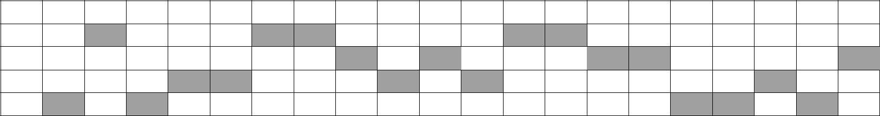

|  |  |  |  |  |  |  |  |  |  |  |  |  |  |  |  |  |  |  |  |
| --- | --- | --- | --- | --- | --- | --- | --- | --- | --- | --- | --- | --- | --- | --- | --- | --- | --- | --- | --- |
| **1** | **2** | **3** | **4** | **5** | **6** | **7** | **8** | **9** | **10** | **11** | **12** | **13** | **14** | **15** | **16** | **17** | **18** | **19** | **20** |

**A**

**B**

**C**

**D**

**Mã đề: 132**

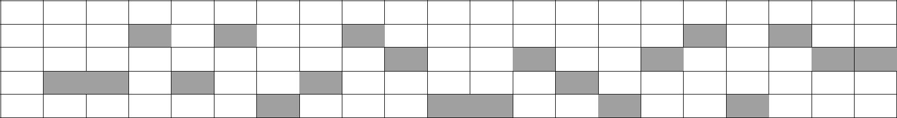

|  |  |  |  |  |  |  |  |  |  |  |  |  |  |  |  |  |  |  |  |
| --- | --- | --- | --- | --- | --- | --- | --- | --- | --- | --- | --- | --- | --- | --- | --- | --- | --- | --- | --- |
| **1** | **2** | **3** | **4** | **5** | **6** | **7** | **8** | **9** | **10** | **11** | **12** | **13** | **14** | **15** | **16** | **17** | **18** | **19** | **20** |

**A**

**B**

**C**

**D**

**Mã đề: 209**

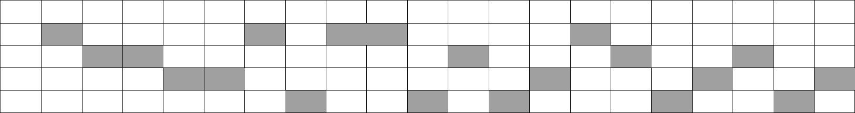

|  |  |  |  |  |  |  |  |  |  |  |  |  |  |  |  |  |  |  |  |
| --- | --- | --- | --- | --- | --- | --- | --- | --- | --- | --- | --- | --- | --- | --- | --- | --- | --- | --- | --- |
| **1** | **2** | **3** | **4** | **5** | **6** | **7** | **8** | **9** | **10** | **11** | **12** | **13** | **14** | **15** | **16** | **17** | **18** | **19** | **20** |

**A**

**B**

**C**

**D**

**HƯỚNG DẪN CHẤM MÔN TOÁN LỚP 12 GIỮA HỌC KỲ II – ĐỀ 132 & 209**

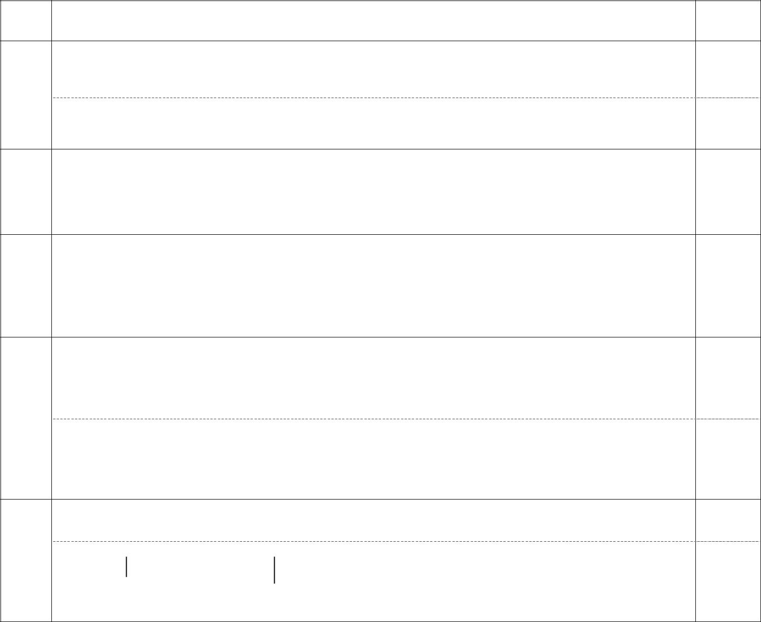

|  |  |
| --- | --- |
| **Bài** | **Nội dung** |

1. F(x)  3x 2  2  dx  x 3 / 2 x/ C

|  |  |  |  |  |  |  |  |  |  |  |  |  |  |  |  |  |  |  |  |  |  |  |  |  |  |  |  |  |  |  |  |  |
| --- | --- | --- | --- | --- | --- | --- | --- | --- | --- | --- | --- | --- | --- | --- | --- | --- | --- | --- | --- | --- | --- | --- | --- | --- | --- | --- | --- | --- | --- | --- | --- | --- |
|  | Mà F(1)  2  C  1/. Vậy: F(x)  x 3  2x 1/ | | | | | | | | | | | | | | | | | | | | | | | | | | | | | | |  |
|  | 1 | | |  | 2 |  |  |  |  |  |  |  |  x 3 | | | | | | 2 |  |  |  |  |  |  | 1 |  |  | 5 |  |  |  |
|  |  |  |  |  |  |  |  |  |  |  |
|  | A  (x | | | |  |  2x  3)dx/   | | | | | | | | | |  |  |  x |  | − 3x  | | | | |  |  | /   | |  |  | / / |  |
|  |  | 3 | |  | 3 | |  |
| **2a** | 0 | | |  |  |  |  |  |  |  |  |  |  | | |  |  |  |  |  |  |  |  | 0 |  |  |  |  |
|  |  |  |  |  |  |  |  |  |  |  |  |  |  |  |  |  |  |  |  |
|  |  | π |  | |  |  |  |  |  |  |  |  |  |  |  |  |  |  |  |  |  |  | π |  | | |  |  |  |  |  |  |
|  |  |  |  |  |  |  x2 | | | | | | |  |  |  |  |  |  | 2 | |  |  |  | π2 | |  |  |  |  |
|  | 2 | |  |  |  |  |  |  |  |  |  |  |  |  |  |  |  |  |  |  |
| **2b** | B  x | | | |  cos x dx   | | | | |  |  |  |  |  |  |  | /  sin x /  | | | |  |  |  |  | | |  | 1 / / | | | |  |
|  |  |  |  |  | 8 |  |
|  | 0 | |  |  |  |  |  |  |  2 | | | | | | |  |  |  |  |  |  | 0 | |  |  |  |  |  |  |  |  |
|  | Đặt t  ln x  dt  | | | | | | | 1 |  |  |  |  |  |  |  |  |  |  |  |  |  |
|  | dx . Đổi cận: x  e  t  1; x  e 2  t  2 | | | | | | | | | | | | | | | | | | | | | | |  |
|  |  |  |
| **2c** |  |  |  |  |  |  |  | x | | | | | | | |  |  |  |  |  |  |  |  |  |  |  |  |  |  |  |  |  |
|  |  |  |  |  |  |  |  |  |  |  |  |  |  |  |  |  |  |  |  |  |  |  |  |  |  |  |  |  |  |  |  |
|  | C  12 | | | t 1 | | | dt /   t  ln | | | |  | t |  |  | |  | 12 /  1  ln 2 / | | | | | | | | | |  |  |  |  |  |  |
|  |  |  |  |  |  |  |  |  |  |
|  |  |  |  |  |  |  |  |  |
|  |  | | |  |  |  |  |  |  |
|  |  | t |  |  |  |  |  |  |  |  |  |
|  |  |  |  |  |  |  |  |  |  |  |  |  |  |  |  |  |  |  |
|  |  |  |  |  |  |  |  |  |  |  |  |  |  |  |  |  |  |  |  |  |  |  |  |  |  |  |  |  |  |  |  |
| **2d** | Đặt: u  x  du  dx ; dv = exdx chọn v = ex | | | | | | | | | | | | | | | | | | | | | | | | | | | |  |  |  |  |

1

D  xe x 10   e x dx/  e  e x 1 / 1 /

0

0

**Điểm**

0.5

0.5

1.0

1.0

0.25

0.75

0.25

0.75

**HƯỚNG DẪN CHẤM MÔN TOÁN LỚP 12 GIỮA HỌC KỲ II – ĐỀ 134 & 210**

|  |  |  |  |  |  |  |  |  |  |  |  |  |  |  |  |  |  |  |  |  |  |  |  |  |  |  |  |  |  |  |  |  |  |  |  |  |  |  |  |  |  |  |  |  |  |  |  |  |  |  |  |  |  |  |  |  |  |  |  |  |  |  |  |  |  |
| --- | --- | --- | --- | --- | --- | --- | --- | --- | --- | --- | --- | --- | --- | --- | --- | --- | --- | --- | --- | --- | --- | --- | --- | --- | --- | --- | --- | --- | --- | --- | --- | --- | --- | --- | --- | --- | --- | --- | --- | --- | --- | --- | --- | --- | --- | --- | --- | --- | --- | --- | --- | --- | --- | --- | --- | --- | --- | --- | --- | --- | --- | --- | --- | --- | --- |
| **Bài** |  |  |  |  |  |  |  |  |  |  |  |  |  |  |  |  |  |  |  |  |  |  |  |  |  |  |  |  |  |  |  |  |  |  | **Nội dung** | | | | | | | | | | | | | | | |  |  |  |  |  |  |  |  |  |  |  |  |  | **Điểm** |  |
|  |  |  |  |  |  |  |  |  | | |  |  |  | | |  |  |  |  |  |  |  |  |  |  |  |  |  | | |  |  | | | |  |  |  | |  |  |  |  |  |  |  |  |  |  |  |  |  |  |  |  |  |  |  |  |  |  |  |  |  |  |
| **1** | F(x)  3x 2  2  dx  x 3 / 2 x/ C | | | | | | | | | | | | | | | | | | | | | | | | | | | | | | | | | | | | | | | | | | | |  |  |  |  |  |  |  |  |  |  |  |  |  |  |  |  |  |  |  | 0.5 |  |
|  | Mà F(1)  3  C  4 /. Vậy: F(x)  x 3  2x  4 / | | | | | | | | | | | | | | | | | | | | | | | | | | | | | | | | | | | | | | | | | | | | | | | | | | | | | | | | | |  |  |  |  |  |  |  |
|  |  |  |  |  |  | 0.5 |  |
|  |  | | | | | | | | | | | | | | | | | | | | | | | | | | | | | | | | | | | | | | | | | | | | | | | | | | | | | | | | | | | | | | |  |  |
|  | 1 | | | | |  |  |  | 2 |  |  |  |  |  |  |  |  |  |  |  |  |  x 3 | | | | | | |  | 2 | | |  |  |  |  |  |  |  |  |  |  |  | 1 |  |  |  |  |  |  | 11 | | | | | |  |  |  |  |  |  |  |  |  |
|  |  |  |  |  |  |  |  |  |  |  |  |  |  |  |  |  |  |  |  |  |  |  |  |  |  |  |  |  |  |  |  |
|  | A  (x | | | | | | | |  | − 2x  3)dx/   | | | | | | | | | | | | | | |  |  |  | − x | |  |  |  | − 3x  | | | | | | | | | |  |  |  | /   | | | | |  |  |  |  |  |  | / / | | |  |  |  |  | 1.0 |  |
|  |  | 3 | | |  |  |  |  |  | 3 | |  |  |  |  |  |  |  |
| **2a** | 0 | | | | | | | | | | | | | |  |  |  |  |  |  |  |  | | |  | | | | | | | | | | |  |  |  |  |  | 0 |  | | | | | | | |  | | | | | | | | |  |  |
|  |  | | | | | | | | | | | | | |  | | | | | | | | | | | | | |  |  | | | | | | | | | | | | | | | | | | |  |  |
|  |  | | | | | | | | | | | | | | | | | | | | | | | | | | | | | | | | | | | | | | | | | | | | | | | | | | | | | | | | | | | | | | |  |  |
|  |  | π | | |  |  | | | | | | | | | | | | | | | | | | | | | | | | | | | | | | | | | | | π |  | | | | | | | | | | | | | | | | | | | | | |  |  |
|  |  |  |  |  |  |  |  |  |  |  |  |  |  x2 | | | | | | | |  |  |  |  |  |  |  |  |  |  |  |  | | |  | 2 | |  |  |  |  | π2 | | | | |  |  |  |  |  |  |  |  |  |  |  |  |  |  |  |
|  | 2 | | |  |  |  |  |  |  |  |  |  |  |  |  |  |  |  |  |  |  |  |  |  |  |  |  |  |  |  |  |  |  |  |  |  |  |  |  |  |  |  |  |  |  | 1.0 |  |
| **2b** | B  x | | | | | | | | − sin x dx   | | | | | | | | |  |  |  |  |  |  |  |  | /  cos x /  | | | | | | | | | | | | |  |  |  |  | | |  |  |  | 1 / / | | | | | | | | | | |  |  |  |  |  |  |  |
|  |  |  |  |  |  | 8 | | |  |  |  |  |  |  |  |
|  | 0 | | |  |  |  |  |  |  |  |  |  |  |  |  |  |  2 | | | | | | | |  |  |  |  |  |  |  |  |  |  |  |  | | |  | 0 | |  |  |  |  |  |  |  |  |  |  |  |  |  |  |  |  |  |  |  |  |  |
|  |  |  |  |  |  |  |  |  |  |  |  |  |  |  |  |  |  |  |  |  |  |  |  |  |  |  |  |  |  |  |  |  |  |  |  |  |  |  |  |  |  |  |  |  |  |  |  |  |
|  | Đặt t  sin x  dt  cos xdx . Đổi cận: x  | | | | | | | | | | | | | | | | | | | | | | | | | | | | | | | | | | | | | | | | | | | | | | π | |  | ⇒ t  | | | | | | | | | | 1 | ; x  | π | ⇒ t 1 | 0.25 |  |
|  |  | | 2 | 2 |  |
| **2c** | 6 | | | | | | | | | | | | | | | | | | | | | | | | | | | | | | | | | | | | | | | | | | | | | | | | | | | | | | | | | | |  |  |  |  |
|  | | | | | | | | | | | | | | | | | | | | | | | | | | | | | | | | | | | | | | | | | | | | | | | | | | | | | | | | | | | | | | |  |  |
|  | C  11 | | | | | | t 1 | | | | dt /   t  ln | | | | | | | |  | t | |  |  | |  | 11 /  | | | 1 | |  |  |  ln 2 / | | | | | | | | | | | |  |  |  |  |  |  |  |  |  |  |  |  |  |  |  |  |  |  |  |  |  |
|  |  |  |  |  |  |  |  |  |  |  |  |  |  |  |  |  |  |  |  |  |  |  |  |  | 0.75 |  |
|  |  |  |  |  |  |  |  |  |  |  |  |  |  |  |  |  |  |  |  |  |  |  |  |
|  |  |  |  |  |  |  |  |  |  |  |  |  |  |  |  |  |  |  |  |  |  |  |
|  |  |  | | |  |  |  |  |  |  |  |  |  |  |  |  |  |  |  |  |  |  |  |  |  |  |  |  |
|  |  | | |  | |  | | | t |  | | | | | | | | |  |  | |  |  | |  | |  | | 2 | |  |  |  | | | | | | | | | | | | | | | | | | | | | | | | | | | | | | |  |  |
|  | 2 | | | | | | | | 2 | | | | | | | | | | | | | | | | | | |  | | | | | | | | | | | | | | | | | | | | | | | | | | | | | | |  |  |
|  |  | | | | | | | | | | | | | | | | | | | | | | | | | | | | | | | | | | | | | | | | | | | | | | | | | | | | | | | | | | | | | | |  |  |
| **2d** | Đặt: u  ln x  du  | | | | | | | | | | | | | | | | dx | | | |  |  |  |  |  |  |  |  |  |  |  |  |  |  |  |  |  |  |  |  |  |  |  |  | v  | | | | | x | | | 2 |  |  |  |  |  |  |  |  |  |  |  |  |
|  |  |  |  |  |  |  |  |  |  |  |  |  |  |  |  |  |  |  |  |  |  |  |  |  |  |  |  |  |  |  |  |  |  |  |  |  |
|  | ; dv = xdx chọn | | | | | | | | | | | | | | | | | | | | | | | |  |  |  |  |  |  |  |  |  |  |  | 0.25 |  |
|  |  |  |  |  |  | | |  |  |  |  |  |  |  |  |  |  |  |  |
|  |  |  |  |  |  |  |  |  |  |  |  |  |  |  |  |  | x | | | | | | | |  |  |  |  |  |  |  |  |  |  |  |  |  |  |  |  |  |  |  |  | 2 | | | | | | | | |  |  |  |  |  |  |  |  |  |  |  |  |
|  |  | | x | | | 2 | |  | | | | | 2 | 2 | x |  | | | | | | | | | | | | | | | | x | | 2 |  | | | 2 |  | | | | | | | | | | | | | | | | 3 | | |  | | | | | |  |  |
|  |  | |  | |  | |  |  | | | | | | | | | | | | | | | |  | |  |  | | | | | | | | | | | | | | | |  | | | | | | 0.75 |  |
|  |  | |  | |  |  | | | | | | | | | | | | | | | |  |  | | | | | | | | | | | | | | | |  | | | | | |  |
|  | D  | |  |  | .ln x | | | |  |  | −  | dx/  2 ln 2  | | | | | | | | | | | | | | | |  |  |  |  |  |  |  | /  | | | | 2 ln 2  | | | | | | | | | |  | / |  |  |  |  |  |  |
|  |  | | |  |  |  |  | |  |  |  |  |  |  |  |  |  |  |  |  |  |  |  |  |  |
|  | 2 | | | | | | |  |  |  | |  | 1 | 1 | 2 |  |  |  |  |  |  |  |  |  |  |  |  |  |  |  |  |  | 4 | |  |  |  | 1 |  |  |  |  |  |  |  |  |  |  |  |  |  |  |  |  | 4 | | |  |  |  |  |  |  |  |  |
|  |  | | | | | | | | | | | | |  | | | | | | | | | | | | | | | | | | | | | | |  | | | | | | | | | | | | | | | | | | | | | | | | |  |  |
|  |  | | | | | | | | | | | | | | | | | | | | | | | | | | | | | | | | | | | | | | | | | | | | | | | | | | | | | | | | | | | | | | |  |  |

